GTB  
  
**QA**  
[DEV 20.42] OT-1039 | XT | BE | NPP | BE NL - NPP pop up for Puma and Kuga – 27 October 2020

**Jira ticket:**  
<https://jira.uhub.biz/browse/GTBEMEAOPT-1039>

**Site**  
 <https://www.nl.ford.be/>

**Test location**  
Puma and Kuga Nameplate Page

**Test Description**

View the QA link. After which go to either the

* Puma Nameplate page
  + <https://www.nl.ford.be/alle-modellen/puma>
* Kuga Nameplate page
  + <https://www.nl.ford.be/alle-modellen/kuga>

After about 8 seconds the popup will appear. See screenshots for examples of what they look like. The only difference between the 2 popups are the words used (Either Kuga or Puma), the image and the button directing to a different URL.

Puma Image: 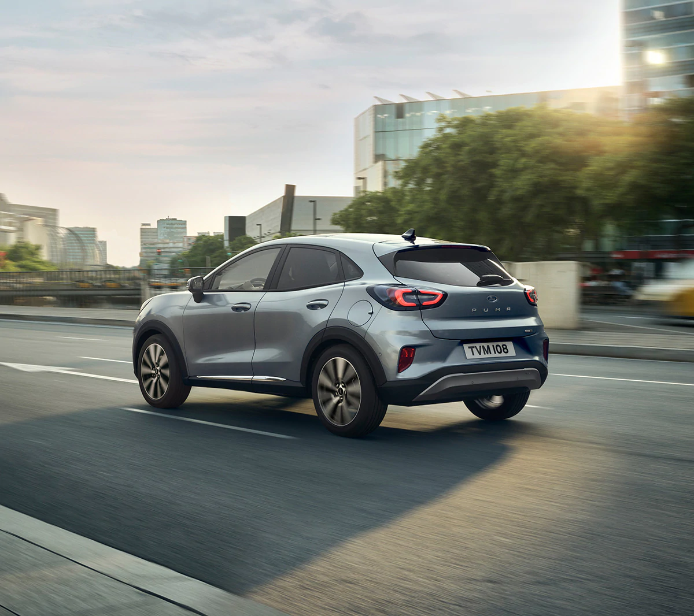

Kuga Image: 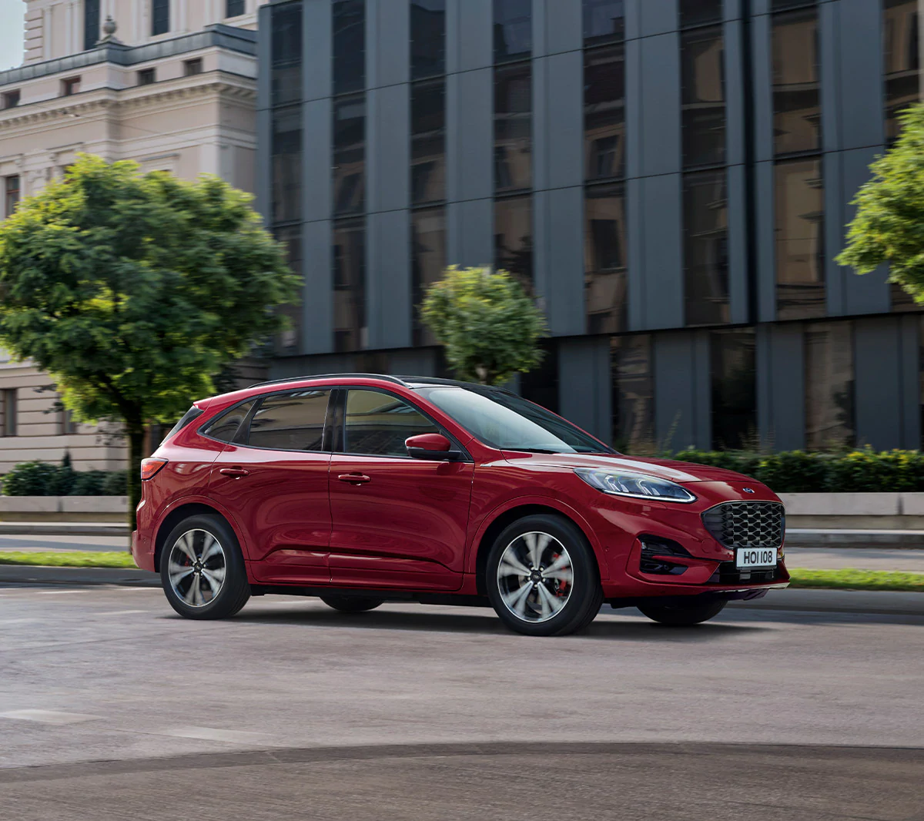

Puma Button URL: <https://www.nl.ford.be/shop/volgende-stappen/bp/ice#/model?catalogId=WAEBX-CF7-2020-BX726BEL202075>

Kuga Button URL: <https://www.nl.ford.be/shop/volgende-stappen/bp/ice#/model?catalogId=WAEBX-CTD-2019-CX482KugaBEL202075>

If you were to go to either the Puma or Kuga Button URL before getting the popup, the popup won’t appear for that vehicle. Same with if you were to view the popup then click on the button, going back to the Nameplate Page won’t have the popup appear. Keep in mind though that if you use the Puma button URL, and you go to the Kuga Nameplate page, the popup will still appear.

Other default popup rules also apply, popup can only be seen up to 3 times and never twice in a 15 minute duration. This counts for both popups. I.E. viewing the Puma popup but then going to the Kuga page will only have the Kuga popup appear after 15 minutes.

Below please find attached screenshots of the Kuga and Puma Popup.

Desktop Kuga: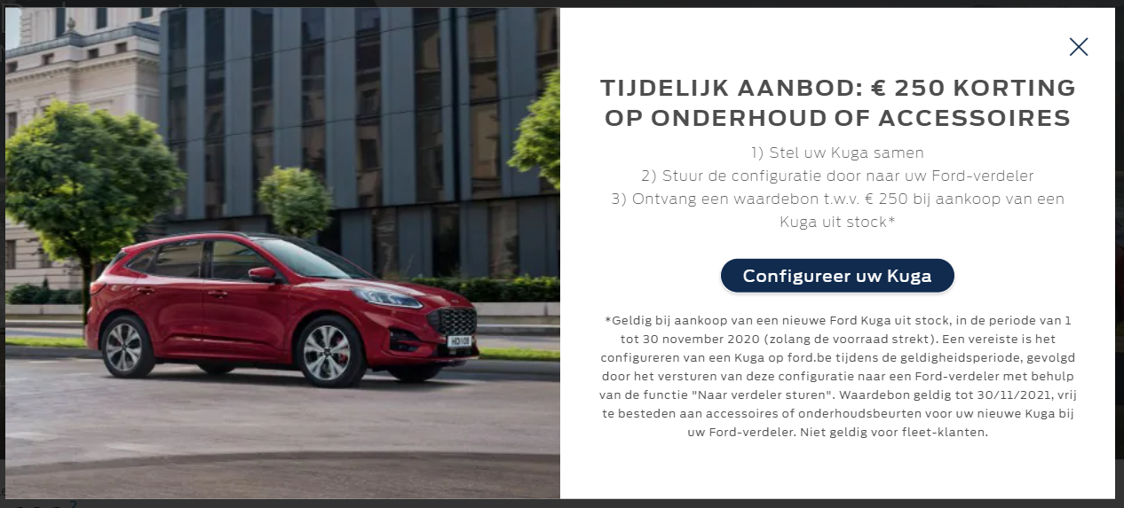

Tablet Kuga: 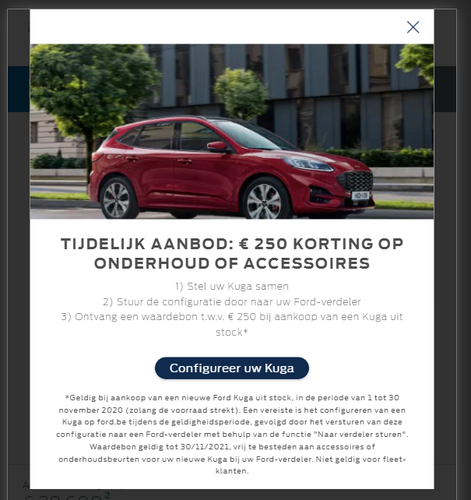

Mobile Kuga:  
 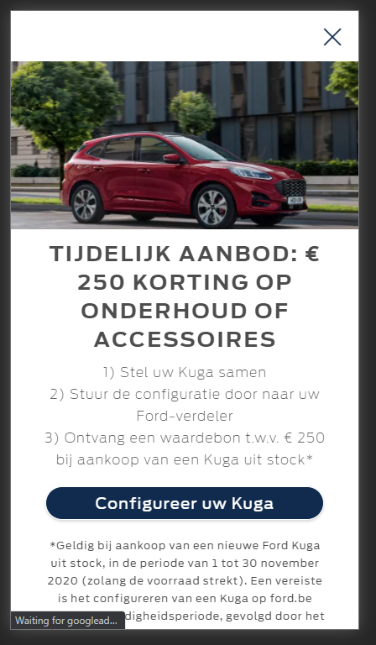

**Browser:**   
All  
  
**Device:**   
All  
  
**Audience rules:**   
All traffic

**QA Link:**

<https://www.nl.ford.be/?at_preview_token=je3wfp4AUIpie7H1w5JIYg&at_preview_index=1_1&at_preview_listed_activities_only=true>